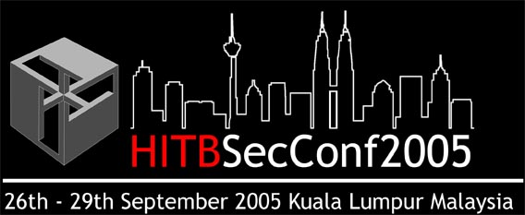
Hack in the Box Security Conference 2005
Open Source Security Software Award & Project Showcase

As part of its continued commitment to 'keeping knowledge free', Hack in the Box is pleased to announce its Open Source Security Software Award.

This award is to encourage the participation of software developers in Open Source development work in general and in security software development in particular as well as to promote quality Open Source software projects in the security arena.

The Hack in the Box Open Source Security Software Award (HITB-OSS Award2005) will be given to an outstanding security software which has been released under at least one of the Open Source Licenses recognized by the Open Source Initiative. This is an ideal opportunity and platform for up and coming security researchers to showcase their works and to highlight new technologies.

The Top 4 submissions (as judged by our selection committee) will be awarded with a chance
to present their software and project at the Hack in the Box Security Conference 2005 (HITBSecConf2005) to be held in Kuala Lumpur, Malaysia on the 28th and 29th September. Each of the 4 project groups will be allocated the following:

- The use of a prime booth for presentation at the HITBSecConf2005 exhibition area
- A 15-minute slot for presentation / demo during the tea breaks (there are 2 breaks per day, as such presentations will be spread across the 2-days.)
- A computer, projector and screen will be provided for the teams use (The team members are expected to furnish all software, additional hardware for example hubs, switches etc that may be necessary for the demo.)
- HITB will arrange with both the international as well as local media to be present during these presentation slots.

Eligibility

To be eligible, applicants should ensure that their security software is at least released under one of the Open Source licenses to be found at the Open Source Initiative website and that it is in working order.

http://www.opensource.org/licenses/index.php

Beta versions can be submitted but preference will be given to a stable release version. The software should also be available for downloading for evaluation by the judges over the Internet (though not necessarily for public downloading).

Judging Criteria

Judging will be done by a committee selected by Hack in the Box and the decision of the judges is final. The software will be judged based on the following criteria:

1.) Software architecture, design and coding with respect to:

- innovation and creativity
- security considerations

2.) Functionalities of the software with respect to its intended use

3.) Preference will be given to a software project that is not in widespread use currently i.e. It should be a new or relatively new project.

4.) The judges decision is final. No late entries will be entertained

5.) Participation is also open to students at all levels in local or foreign institutes of higher education. Students are strongly encouraged to submit.

6.) Participants must be able to demonstrate working and functional software. This means that no conceptual design work or ideas will be accepted. Pre-release, and beta software are accepted as long as it can demonstrate more than 70% of its intended functionalities.

Details of Submission

Interested applicants are requested to fill out the details in the prescribed form and email it to following address:

The closing date for submission is Friday 9th September 2005. The 4 short listed teams will be contacted by Monday 12th September 2005.

Form for Submission
Hack in the Box Security Conference 2005
Open Source Security Software Award & Project Showcase

Please fill in and email the completed form to the address below:
hitb-ossps@hackinthebox.org

Closing Date is Friday 9th September 2005.

A: PROJECT DETAILS

Name of Project:
Principal Developer(s):
Public Website (if any):
University Name (if any):
Contact Person:
Name:
Email:
Telephone:
Fax:

B: SOFTWARE DETAILS

Name of Software:

Software License:

Description (including objective):

Brief History (including start date of project and current version):

Main Features and Functionalities:

Future Enhancements:

Innovative Technologies Used (if any):

C. SOFTWARE AVAILABILITY

Website for software:
Download Details:

